YQIYNI

Emojis

Characters

[](https://emojipedia.org/woman-light-skin-tone/)[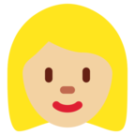](https://emojipedia.org/woman-medium-light-skin-tone/)[](https://emojipedia.org/woman-medium-skin-tone/)[](https://emojipedia.org/woman-medium-dark-skin-tone/)[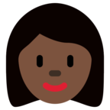](https://emojipedia.org/woman-dark-skin-tone/)[](https://emojipedia.org/woman-light-skin-tone-red-hair/)

[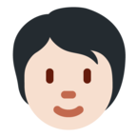](https://emojipedia.org/person-light-skin-tone/) [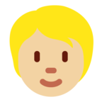](https://emojipedia.org/person-medium-light-skin-tone/)[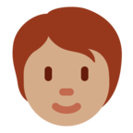](https://emojipedia.org/person-medium-skin-tone/)[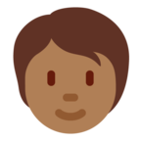](https://emojipedia.org/person-medium-dark-skin-tone/)[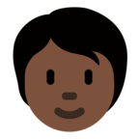](https://emojipedia.org/person-dark-skin-tone/)[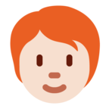](https://emojipedia.org/person-light-skin-tone-red-hair/)

[](https://emojipedia.org/grinning-cat/)

[](https://emojipedia.org/grinning-face/)

Transportation

[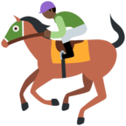](https://emojipedia.org/horse-racing-dark-skin-tone/)[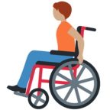](https://emojipedia.org/person-in-manual-wheelchair-medium-skin-tone/)[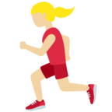](https://emojipedia.org/woman-running-medium-light-skin-tone/)[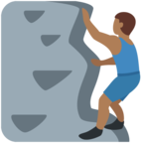](https://emojipedia.org/man-climbing-medium-dark-skin-tone/)[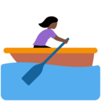](https://emojipedia.org/woman-rowing-boat-dark-skin-tone/)[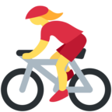](https://emojipedia.org/woman-biking/)

Emotions

[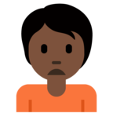](https://emojipedia.org/person-frowning-dark-skin-tone/)[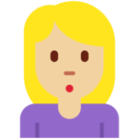](https://emojipedia.org/woman-pouting-medium-light-skin-tone/)[](https://emojipedia.org/man-gesturing-no-medium-skin-tone/)[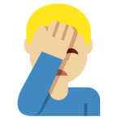](https://emojipedia.org/man-facepalming-medium-light-skin-tone/)[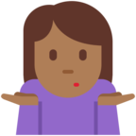](https://emojipedia.org/woman-shrugging-medium-dark-skin-tone/)[](https://emojipedia.org/ok-hand-dark-skin-tone/)[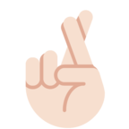](https://emojipedia.org/crossed-fingers-light-skin-tone/)[](https://emojipedia.org/thumbs-up-medium-skin-tone/)[](https://emojipedia.org/clapping-hands-medium-dark-skin-tone/)